 | Computer Organization and Assembly Language (EL-2003)
Semester: Fall 2025
Section: BCS-3J / BCS-3K
Course Instructor: Seema Hashwani
LAB # 03

Data and its Types, Definition statement & Assembly Instructions

Lab Objectives:
By the end of this lab, students will be able to:
- Understand the role of registers as small, fast storage units in the CPU used for data manipulation during execution.
- Learn how to define data by declaring variables or constants in memory for assembly programs.
- Use data definition statements with directives like BYTE, WORD, and DWORD to reserve memory and specify data types.
- Perform data initialization by assigning initial values to variables at the time of declaration.
- Implement multiple initializations to define several values in a single statement, useful for arrays or sequences.
- Initialize strings by declaring sequences of characters stored in memory.
- Apply basic assembly language instructions such as MOV, ADD, and SUB for data transfer and arithmetic operations.
- Develop and analyze a sample program demonstrating data definitions and fundamental instructions.

Basic Program Execution Registers

Introduction to Registers
A register is a high-speed storage location directly inside the CPU, designed to be accessed at much higher speed than conventional memory. When a processing loop is optimized for speed, for example, loop counters are held in registers rather than variables. Figure 1 shows the basic program execution registers. There are eight general-purpose registers, six segment registers, a processor status flags register (EFLAGS), and an instruction pointer (EIP).

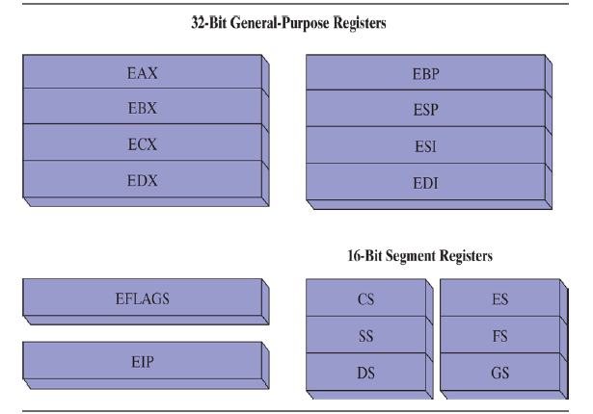
Figure 1: Basic program execution registers.
General-Purpose Registers
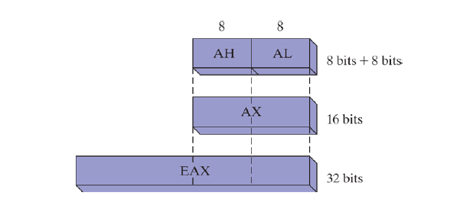
The general-purpose registers are primarily used for arithmetic and data movement. As shown in Figure 2, the lower 16 bits of the EAX register can be referenced by the name AX.
Figure 2: General-purpose registers.
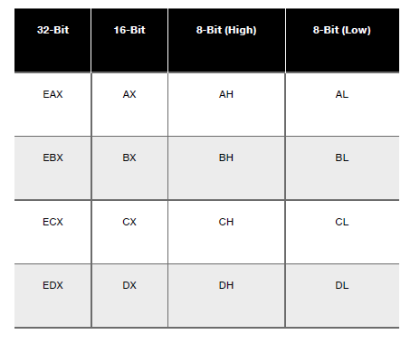
Portions of some registers can be addressed as 8-bit values. For example, the AX register has an 8-bit upper half named AH and an 8-bit lower half named AL. The same overlapping relationship exists for the EAX, EBX, ECX, and EDX registers:
The remaining general-purpose registers can only be accessed using 32-bit or 16-bit names, as shown in the following table:
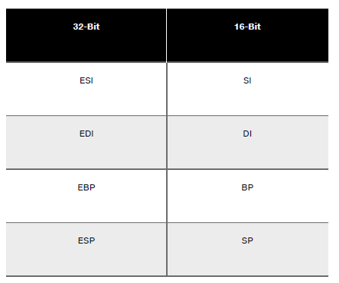

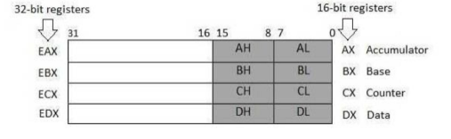
AX (Accumulator): It is used in input/outpul and most arithmetic instructions. For example, in
multiplication operation, one operand is stored in EAX or AX or AL register according to the size
of the operand.

BX (Base register): It could be used in indexed addressing.

CX (Counter register): The ECX, CX registers store the loop count in iterative operations.

DX (Data register): It is also used in input/output operations. It is also used with AX register
along with DX for multiply and division operations involving large values.

Pointer Registers
The pointer registers are 32-bit EIP, ESP, and EBP registers and corresponding 16-bit right
portions IP, SP, and BP. There are three categories of pointer registers:

Instruction Pointer (IP): The 16-bit IP register stores the offset address of the next instruction to
be executed. IP in association with the CS register (as CS:IP) gives the complete address of the
current instruction in the code segment.

Stack Pointer (SP): The 16-bit SP register provides the offset value within the program stack.
SP in association with the SS register (SS:SP) refers to be current position of data or address
within the program stack.

Base Pointer (BP): The 16-bil BP register mainly helps in referencing the parameter variables
passed to a subroutine. The address in SS register is combined with the offset in BP to get the
location of the parameter. BP can also be combined with DI and SI as base register for special
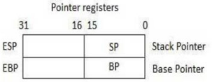
addressing.

Index Registers
The 32-bit index registers, ESI and EDI, and their 16-bit rightmost portions. SI and DI, are used
for indexed addressing and sometimes used in addition and subtraction. There are two sets of index pointers.

Source Index (SI): It is used as source index for string operations.

Destination Index (DI): It is used as destination index for string operations.
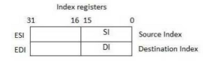

Defining Data

Intrinsic Data Types:
The assembler recognizes a basic set of intrinsic data types, which describe types in terms of their size (byte, word, doubleword, and so on), whether they are signed, and whether they are integers or reals. There’s a fair amount of overlap in these types—for example, the DWORD type (32-
bit, unsigned integer) is interchangeable with the SDWORD type (32-bit, signed integer). You might say programmers use SDWORD to communicate to readers that a value will contain a sign, but there is no enforcement by the assembler. The assembler only evaluates the sizes of
operands. So, for example, you can only assign variables of type DWORD, SDWORD, or REAL4 to a 32-bit integer. In the given table contains a list of all the intrinsic data types. The notation IEEE in some of the table entries refers to standard real number formats published by the IEEE
Computer Society.

Data Definition Statement:
A data definition statement sets aside storage in memory for a variable, with an optional name. Data definition statements create variables based on intrinsic data types. A data definition has the following syntax:
[name] directive initializer [,initializer]...

Initializer: At least one initializer is required in a data definition, even if it is zero. Additional
initializers, if any, are separated by commas. For integer data types, initializer is an integer constant or expression matching the size of the variable’s type, such as BYTE or WORD. If you prefer to leave the variable uninitialized (assigned a random value), the ? symbol can be used as the initializer.
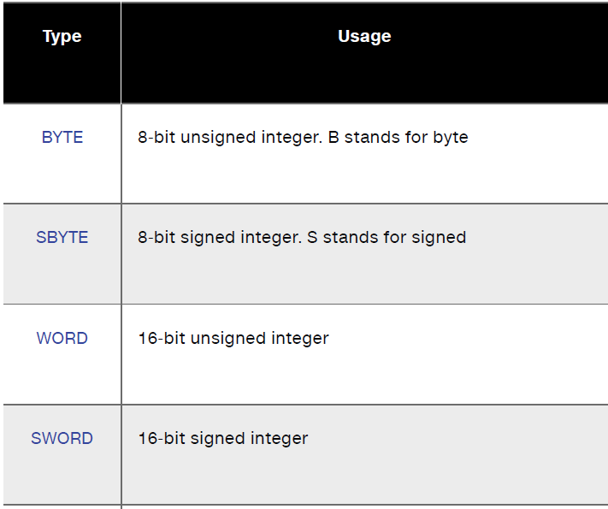
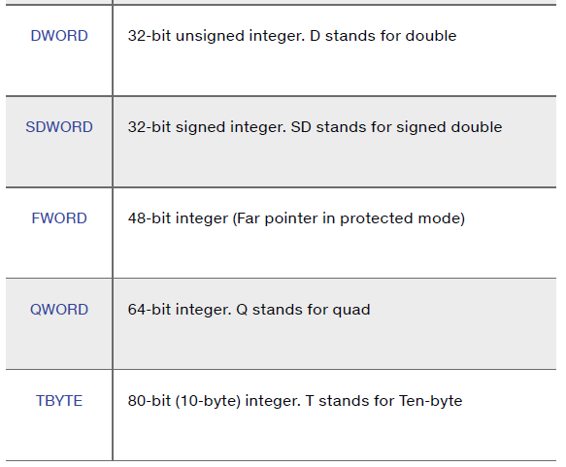

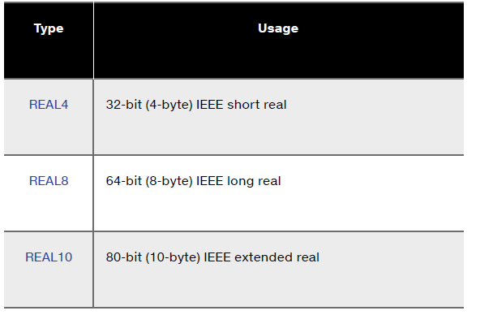

Examples:
value1 BYTE 'A' ; character constant
value2 BYTE 0 ; smallest unsigned byte
value3 BYTE 255 ; largest unsigned byte
value4 SBYTE −128 ; smallest signed byte
value5 SBYTE +127 ; largest signed byte
greeting1 BYTE "Good afternoon”, 0 ; String constant
greeting2 BYTE 'Good night' ,0 ; String constant
list BYTE 10,20,30,40 ; Multiple initializers
Note: A question mark (?) initializer leaves the variable uninitialized, implying it will be assigned a value at runtime:
value6 BYTE ?
DUP Operator:
The DUP operator allocates storage for multiple data items, using a integer expression as a counter. It is particularly useful when allocating space for a string or array, and can be used with initialized or uninitialized data:
Examples:
BYTE 20 DUP(0) ; 20 bytes, all equal to zero
BYTE 20 DUP(?) ; 20 bytes, uninitialized
BYTE 4 DUP("STACK") ; 20 bytes: "STACKSTACKSTACKSTACK"

Operand Types:
As x86 instruction formats:
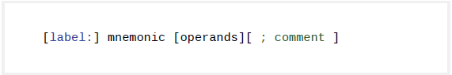
Instructions can have zero, one, two, or three operands. Here, we omit the label and comment fields for clarity:

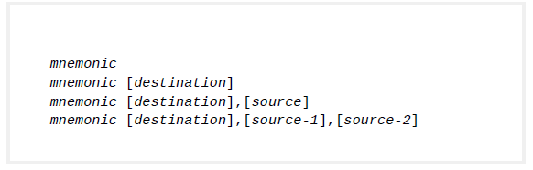
There are three basic types of operands:
- Immediate operand — uses a numeric or character literal expression
- Register operand — uses a named CPU register
- Memory operand — references a memory location

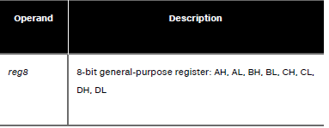
Given Table describes the standard operand types. It uses a simple notation for operands (in 32-bit mode) freely adapted from the Intel manuals. We will use it from this point on to describe the syntax of individual instructions.
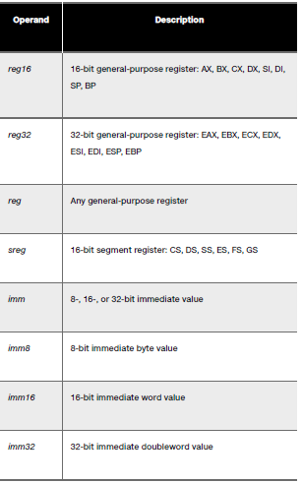
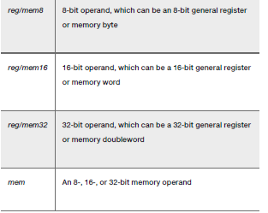
MOV Instruction:
The MOV instruction copies data from a source operand to a destination operand. Known as a data transfer instruction , it is used in virtually every program. Its basic format shows that the first operand is the destination and the second operand is the source:
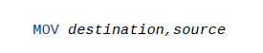

The destination operand’s contents change, but the source operand is unchanged. The right to left movement of data is similar to the assignment statement in C++ or Java:
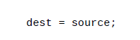

In nearly all assembly language instructions, the left-hand operand is the destination and the right-hand operand is the source. MOV is very flexible in its use of operands, as long as the following rules are observed:
- Both operands must be the same size.
- Both operands cannot be memory operands.
- The instruction pointer register (IP, EIP, or RIP) cannot be a
destination operand.

Here is a list of the standard MOV instruction formats:
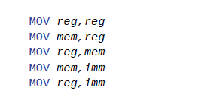
Example:
MOV bx, 2
MOV ax, cx

Example:
‘A’ has ASCII code 65D (01000001B, 41H)
The following MOV instructions stores it in register BX:

MOV bx, 65d
MOV bx, 41h
MOV bx, 01000001b
MOV bx, ‘A’
All of the above are equivalent.

Examples:
The following examples demonstrate compatibility between operands used with MOV
instruction:
ADD Instruction
The ADD instruction adds a source operand to a destination operand of the same size. Source is unchanged by the operation, and the sum is stored in the destination operand
Syntax:
ADD dest,source

SUB Instruction
The SUB instruction subtracts a source operand from a destination operand.
Syntax:
SUB dest,source

Sample Program:
TITLE Add and Subtract (AddSub.asm)
; This program adds and subtracts 32-bit integers.
INCLUDE Irvine32.inc
.code
main PROC
mov eax,10000h ; EAX = 10000h
add eax,40000h ; EAX = 50000h
sub eax,20000h ; EAX = 30000h
call DumpRegs ; display registers
exit
main ENDP
END main

